My Bride - Receive Me With Joy
July 20, 2026

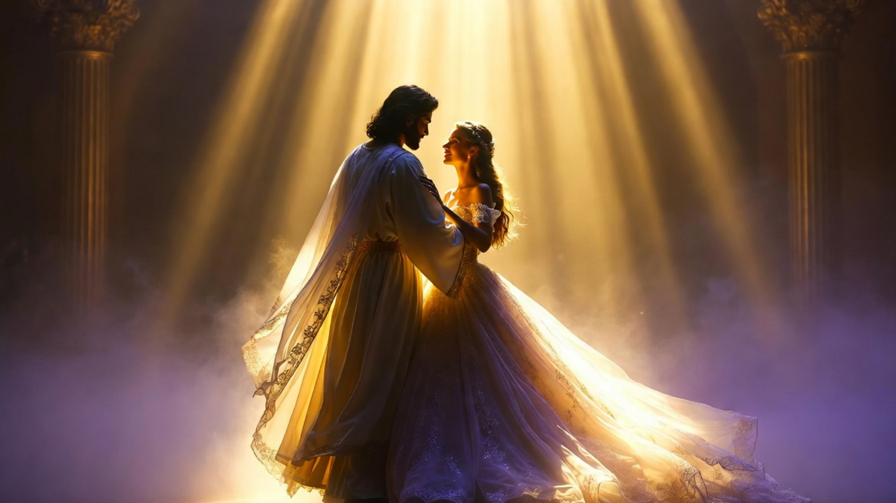
May the sweet, restoring presence of Jesus be with you, Heartdwellers.
Today at morning Mass in the chapel during the worship, the Lord was dancing with His Bride. His presence was so very sweet in the room and very calming and peaceful, yet there was a tenderness about the dance.
He has been asking for a deeper consecration from us in order for us to grow and be able to hold the very special gifts we long to exercise to help others who are sick or confused and provide them with healing and comfort. He is focusing on self-denial and carrying suffering with a heart of joy to give us strength for the journey. He is drawing us in sublime bridal love to move with the worship music on the dance floor of heaven.
As I was drawn into this perfectly heavenly embrace, I noticed my bridal gown, pearl white with layers of sheer gold and lavender highlights twinkling as we moved. The message was clear. The luminescent white gown against my body speaks of the purity of the pearl of great price. The gold represents royalty, for in that moment I was the King’s Bride, and the lavender highlight represented a life peppered with self-denial and suffering for the sake of others.
Believe me, guys, I’m a total coward when it comes to suffering. Somehow, He manages to get me through it.
In that moment, as we were dancing, the Lord spoke to me and said, “Those who suffer the most resemble Me the most.” And even though the scene in the ballroom was bathed in shining elegance and the music holy, still He chose to bring up suffering for the sake of others so that we could be conformed to His likeness.
I answered, “Lord, I am not strong enough, but I’m willing to be made willing. You’ve proven Your faithfulness over 80 years. And when I’m at my weakest, You step in and accomplish it with Your power, which is so subtle I don’t even perceive it. One minute I have a problem and the next minute it’s gone. You amaze me, Jesus.”
He replied, “And I am amazed at all of you who love Me so much. You are willing to live as I lived and receive the same measure of scorn and contempt. This truly proves your love for Me. When others scoff and abandon Me, you continue to follow. How beautiful is the place I have prepared for you who love Me more than your very own selves. Those of you who have dedicated all your life and gifts to the building of My kingdom. Make it all worthwhile for Me.
I love you, My brides, and I love to dance with you during worship. Do not be afraid to see us together this way. You are not imagining it. Rather, it is taking place in real time in the spirit realm. This is a grace and a gift from Me to you.
My people, I have brought heaven down to earth because you need a peaceful place to shelter and receive My healing love. You cannot continue in this darkening atmosphere without glimpses of heaven and real touches of My healing love. As concerns discernment, the proof is in the peace you experience after an encounter such as this.”
In truth, the Lord wants to comfort you between your assignments and spiritual warfare. You cannot continue without a space of peace and rest. When you come into prayer, very often you put everything you have into intercession for your brothers and sisters around the world who are suffering. When you do this they are relieved, but you are drained, and His heart is moved to pity for you, so He wants to restore you.
Don’t be afraid to dance with Him or sit by the river and just be together. This is His delight. So, enjoy Him as much as He enjoys you. And do not write off your visions as delusional. Rather, embrace them as His provision to counter the increasing darkness.
Welcome Him, My brides. Embrace Him in perfect purity and joy of heart. Let Him saturate you in His love.
And that was the end of His short message.
My precious Heartdwellers family, you cannot give love you have not received. You need to be repaired and filled with fresh love from His heart. And that’s why He draws you into this. He truly wants you to feel His love for you. And by the way, He cherishes the love you have for Him.

